Convert Avro File to JSon type File using Hive.

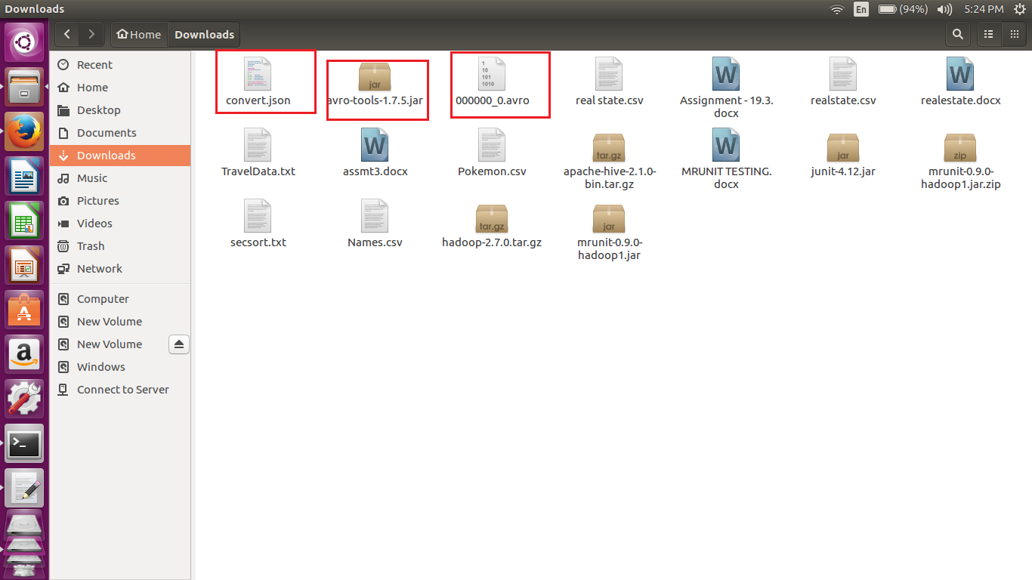

A the Avro file was taken as input 000000_0.avro which can been be seen in file.

For converting the avro to JASON we are using the avro-tools-1.7.5.jar.

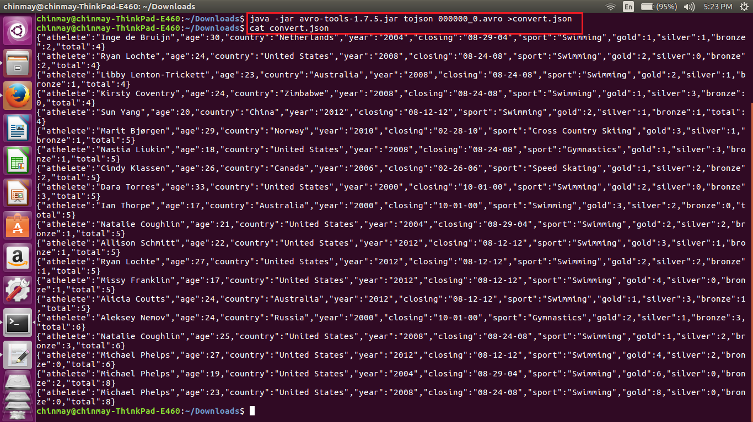

Now we can see using the above jar file and the avro file as input we have generated the new file called as the convert.json.

This convert.json generated can be seen in the first screenshot